Encapsulation and Polymerisation of White Phosphorus Inside Single-wall Carbon Nanotubes
Single-walled carbon nanotubes have been used to encapsulate many types of materials since their discovery, but none have been quite as extreme as white phosphorus. Researchers from University College London, Imperial College London and Cambridge have not only achieved this but have also visualised new phases of phosphorus which have formed within the as recently reported in Angewandte Chemie (http://dx.doi.org/10.1002/anie.201703585).
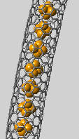
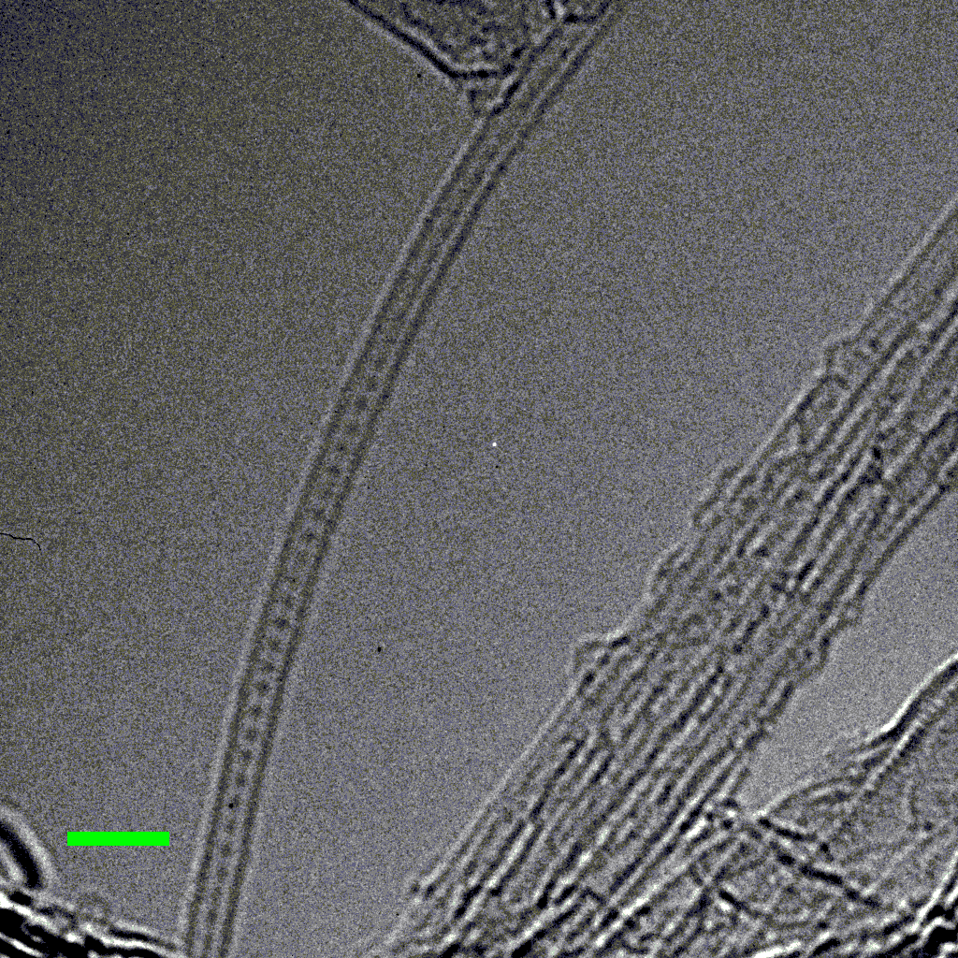
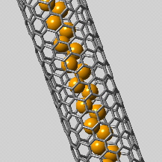
White phosphorus is a material which has a rich but often sinister history. It is an extremely reactive element which burns ferociously whilst expelling huge plumes of white smoke which has seen this element frequently used for military purposes. Yet this is just one of a vast array of allotropes that phosphorus exhibits. Red, violet, blue and black have all been isolated and now a whole field has been created to examine phosphorene, a graphene analogue of single layered black phosphorus. Recently, groups have found ways to stabilise the white allotrope to help store the material safely or recover the material in cases of spills.
Figure 1. (a) HRTEM image of a SWCNT filled with a string of P₄ molecules. (b) Noise-filtered HRTEM image of the region highlighted in (a). (c) Simulated HRTEM image and (d) the corresponding atomic structure of P₄@SWCNT. Panels (b-d) are shown at the same scale. (e) Noise-filtered HRTEM image of polymerised phosphorus. (f) Simulated HRTEM image and (g) the corresponding atomic structure of a single zig-zag chain@SWCNT. Panels (e-g) are shown at the same scale.
b)
c)
d)
a)
e)
f)
g)
2 nm
We have shown that the hollow cavity within single-walled carbon nanotubes can prevent the oxidation of white phosphorus and due to the size of the cavity, can store up to 9 wt% of white phosphorus which is an improvement on other methods. Amazingly, the white phosphorus has been seen to undergo phase transitions whilst exposed to an electron beam. Using the Titan microscope at Imperial College London, the polymerisation of the white phosphorus tetrahedra has been visualised and various new phases of phosphorus have been observed.
This discovery could help determine the mechanism of the white-red phosphorus phase transition and could be used to help mould new phases of phosphorus.

