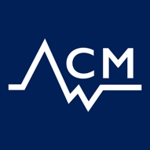
CDT-ACM PhD Project 2019
Project Title: Low temperature sulphidation-related stress corrosion cracking of single crystal superalloys
Project Supervisors:
Supervisor 1: Mary Ryan m.p.ryan@imperial.ac.uk https://www.imperial.ac.uk/people/m.p.ryan
Supervisor 2: Stella Pedrazzini s.pedrazzini@imperial.ac.uk -https://www.imperial.ac.uk/people/s.pedrazzini
With Prof David Rugg (Rolls-Royce), david.rugg@rolls-royce.com

Techniques involved: XANES/ synchrotron surface science, atom probe tomography, STEM-EDX, FIB-SIMS

Short description
The £1.4bn cracking problem on the Trent 1000 turbine blades are related to a new mechanism of sulphur-related stress corrosion cracking in nickel superalloys that had not previously been experienced in civil aero engines, which has inspired a programme of research to understand the underlying mechanisms in order to aid mitigation and resolution of the issue.

